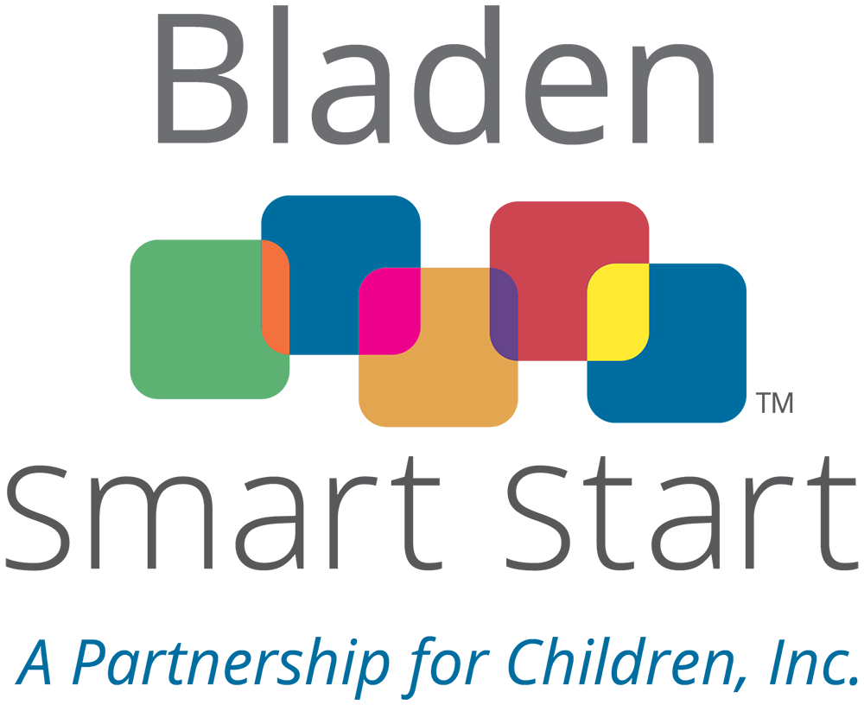
Bladen Smart Start – A Partnership for Children, Inc.
Request for Smart Start Proposals
FY 2026-2027 & 2027-2028

Bladen Smart Start- A Partnership for Children, Inc. is seeking qualified organizations with expertise in early childhood to support our local community with evidence-based or evidence-informed services for children who birth to five and their families in the fiscal years of 2026-2027 & 2027-2028.
This proposal will be for the program: TA Consultation & Coaching: Family Engagement. It includes the Smart Solution listed here: TA Consultation & Coaching: Family Engagement, TA Consultation & Coaching: Start Up, TA: Other Support to ECE, and DCDEE Approved Trainings. The accompanying Smart Solutions to this program can be found here: Smart Solutions Catalog
RFA Release Date: | April 28, 2026
Deadline for Questions: | May 8, 2026, at 5:00 p.m.
Submit Questions to: | Matthew Schaeffer, Executive Director  execdiretor@bcpfc.org
Deadline for Proposals: | May 18, 2026, at 5:00 p.m.
Electronic Submission: | Attention: Matthew Schaeffer  execdirector@bcpfc.org
Mailed to: | Mailing Address  P.O. BOX 2255, Elizabethtown, NC 28337

Applications will be submitted electronically and in hard copy format no later than the time listed above. Late applications will not be accepted. Faxed applications will not be accepted.

I. GENERAL INFORMATION
Introduction
Smart Start is North Carolina’s nationally recognized and award-winning early childhood initiative designed to ensure that every young child living in North Carolina enters school healthy and ready to succeed. Bladen Smart Start – A Partnership for Children, Inc. is the local non-profit organization that administers Smart Start funds in Bladen County. We collaborate with existing programs and support the creation of new ones to measurably strengthen families and improve the lives of their youngest children.
Purpose of the Request
Bladen County’s early care and education (ECE) system faces ongoing challenges related to workforce capacity, program quality, and meaningful family engagement, all of which directly impact children’s readiness for school and long-tern success. Many ECE professionals, from entry-level staff to program administrators, need continued access to high-quality, DCDEE approved training to strengthen their knowledge and skills. At the same time, providers benefit from targeted technical assistance (TA), including consultation and coaching, to address specific programmatic, staff, or child/family needs. New and emerging child care programs also require structed start-up support to successfully launch and transition into sustainable, high-quality operations. Additionally, providers often encounter short-term challenges, such as implementing inclusive practices, supporting social-emotional development, or strengthening family engagement, the require timely, specialized support.
To address these needs, Bladen Smart Start – A Partnership for Children, Inc. invests in a coordinated set of Smart Solutions, including DCDEE approved trainings, TA for family engagement, start-up support, and other targeted TA services. These efforts are designed to increase teacher and director knowledge, strengthen family engagement practices, and improve overall ECE program quality through consistent, relationships-based coaching and consultation. The projected outcomes include a more skilled and confident workforce, higher-quality learning environments, and stronger partnerships between families and providers. Collectively, these services directly align with Bladen Smart Start’s mission to ensure that every child, birth to five, has an equal and fair opportunity for success by building a stronger, more responsive ECE system that meets the diverse needs of children and families.

II. AVAILABLE FUNDING AND ELIGIBILITY REQUIREMENTS
Award Term and Requirements
Funding for this project is provided for a 2-year term and is contingent on funding availability and adherence to the requirements of the grant.
- The term of any resulting award is anticipated to be for 2 fiscal years, from July 1, 2026, until June 30, 2028.
- The bidder must submit annual budgets ending June 30th with its proposal. Contracts for subsequent fiscal years in the multi-year bidding period will be executed only after a satisfactory evaluation of performance, availability of funds, and review and approval of proposed activities. Expenditures must be in accordance with Smart Start Cost Principles and as described in the Chart of Accounts provided by the North Carolina Partnership for Children.
- Funds may not be used for goods or activities that are currently funded by other government sources to ensure no supplanting of funds.
- The legislatively mandated 19% cash and in-kind contribution requirement is required that may include, but is not limited to, parent and community volunteer time, donations of goods and services, etc.
- A background check of each person providing direct services to children under the contract will be required at the expense of the Direct Service Provider in accordance with the Partnership’s policy.

- Bladen Smart Start will not contract with any applicant that fails to provide all required information and documentation. After all required information and documentation has been submitted, Bladen Smart Start will prepare the contract, notify the applicant, and submit the contract for signature.

- If proposals are rejected, applicants will be notified promptly by Bladen Smart Start.

If the application/proposal is approved for funding the applicant must agree to comply with the following pre-contracting list of requirements:
- Work collaboratively with Bladen Smart Start and across agency lines in a community context, to include:
  - Provide updates immediately if leadership of organization is changing; Bladen Smart Start must be informed prior to changes occurring.
  - Any changes that are going to be made to the program as it is outlined in the proposal; Bladen Smart Start must be informed prior to changes occurring.
- Regularly disclose that the activity receives funding from Smart Start and Bladen Smart Start.
- Be available for monitoring visits and meetings held by Bladen Smart Start.
- Comply with fiscal, program and evaluation reporting requirements and deadlines. Agree to evaluation of data collection to capture information around racial equity.
- Revert funds not spent by the end of the fiscal year, unless requested to do so prior to that date.
- Understand that funds must be spent according to the North Carolina Partnership for Children (NCPC) Smart Start Cost Principles (found at www.bladensmartstart.org). If contract terms are not met, funds may be discontinued and any unspent funds returned to Bladen Smart Start.
- Comply with NCGS 143C-6.2 reporting requirements https://www.ncleg.net/EnactedLegislation/Statutes/HTML/BySection/Chapter_143C/GS_143C-6-23.html
- Participate in any audit/evaluation of Bladen Smart Start that is required by the NC General Assembly or any other State officials/agencies.
- Maintain the necessary fidelity bond and commercial liability insurance coverage required.
- Return items purchased with Smart Start funds should the entity no longer perform the services for which the assets were purchased.
- Provide the following information for the contract administrator – name; title; telephone and fax numbers; and mailing address, including street address and zip code.
- If a non-profit entity, provide a copy of the Internal Revenue Code 501(c)3 determination letter received from the IRS.
- Provide No Overdue Taxes Certification.
- Provide a Board of Directors list (if a 501(c)3).
- Provide a copy of the Board Approved Bylaws (if a 501(c)3).
- Provide proof of insurance which may include, but not be limited to, the following:
  - Workers’ compensation.
  - General business liability.
  - Professional liability.
  - Fidelity bonding (e.g. employee crime or dishonesty).
  - Automobile (owned, hired or non-owned).
- Completed Internal Revenue Service (IRS) Form W-9.
- Must provide most recent audit report and/or financial statements.

Eligibility
  - Eligible applicants include non-profit, government agencies, community-based organizations and institutions of higher education with experience in delivering services to children, their families and child care professionals.
  - All proposals must impact children from birth through age five, not yet in Kindergarten. Programs directed at children older than five cannot be considered, by legislative mandate. Only Evidence-Based/Evidence-Informed Programming found in Smart Solutions will be accepted.
  - To be eligible to apply for this funding, applicants must demonstrate sound organizational and fiscal capacity. Funds should be used for activities, experiences, or other resources that have a beneficial impact on children and follow Smart Start legislative mandates and Cost Principles.
  - In addition, eligible applicants’ programs must be located and provide the service within Bladen County. This is to ensure that applicants and their providers have a strong understanding of our community’s needs and assets while having established relationships with other stakeholders.
  - The applicant must provide details of any pertinent judgment, criminal conviction, investigation or litigation pending against the applicant or any of its officers, directors, employees, agents or subcontractors of which the contractor has knowledge, or a statement that there is none. Bladen Smart Start reserves the right to reject a proposal based on this information.

Selection Process
All applications received by the required deadline will be reviewed to ensure all necessary attachments and documentation are complete and included. Applications that are incomplete, late, or submitted by non-eligible applicants will not be reviewed by the Finance & Governance Committee. Nothing may be added to any application after it has been submitted, including a signed certification page. Complete applications from eligible applicants will then be forwarded for review by the Finance & Governance Committee who will review, score and rank the applications.
Applicants may be required to make a 15-minute presentation to the Finance & Governance Committee of the Bladen Smart Start Board to briefly describe their activity and answer specific questions. Presentation times, if needed, will be scheduled after proposal submission.
The Finance & Governance Committee will meet to formulate recommendations to the full Board. Committee members will not include any representative who may have a conflict of interest regarding any funding decision.
Award notices will be provided after May 27, 2026, Bladen Smart Start Board of Directors meeting, but no later than June 15, 2025.
The Finance & Governance Committee will be recalled IF funding levels made by the General Assembly are not adequate to fully meet the approved program budgets.

IV. SUBMISSION INSTRUCTIONS

Application/Proposal Format
Applications (proposals) must include the following components to be considered complete and responsive for funding. All documents are available at www.bladensmartstart.org. Incomplete applications (proposals) will not be reviewed or scored:
- Cover Letter
- RFP Application (Attachment A - including signatures)
- Program Description & selected Smart Solutions
- RFP Attachment B (Excel Worksheet)
  - Budget Narrative/Personnel Listing (2 years)
  - Logic Model tab (2 years)
- Supporting Documents (Attachment C)
- Three (3) Letters of Support
- Written Program Guidelines
- Most recent audited financial statements
- List of Board of Directors (if applicable)

Basic Format:

- The proposal should be typed, on 8 ½” x 11” white paper.
- Use Times New Roman. 12-point font
- Respond to each criterion in the order listed in the Application Narrative.
- Page limit of the narrative is 9 and total page limit with attachments is 11 pages
- Electronic submissions should be sent as attachments in pdf format.
- In addition, hard copies should be submitted and should include 1 original and 8 copies
- The RFP Attachment B should be completed in, and submitted as, an Excel workbook, no PDFs will be accepted

Application Deadline

All applications must be received by 5:00 p.m. on May 18, 2026.

- One (1) electronic submission of the Application, Attachment B, and if applicable, new applicant documents, should be sent to execdirector@bcpfc.org and must be received on or before the due date/time.
- One (1) signed original and 8 copies should be submitted via mail on or before the due date/time. Addressed to: Bladen Smart Start – A Partnership for Children, Inc., P.O. BOX 2255, Elizabethtown, NC 28337
- Late and/or incomplete proposals will not be accepted.
- Signed, emailed or scanned electronic copies sent to the named person on the application cover sheet are acceptable. Faxed copies are not accepted.
- For applicants without scanning capability, an original and 8 copies with required signatures must be mailed to Bladen Smart Start by 5:00 p.m. on the application due date of May 18, 2026.
Additional Requirements Upon Selection
Upon selection, the Local Partnership will contact the Contractor to obtain information and documentation required for preparation of the contract to include the following:
- Name; title; telephone and fax numbers; and mailing address, including street address and zip code, of the contract administrator.
- If a nonprofit entity, a copy of the Internal Revenue Code § 501(c)3 determination letter received from the IRS.
- No Overdue Taxes Certification.
- Board of Directors list (if a 501(c)3).
- Bylaws (if a 501(c)3).
- Proof of insurance that may include, but not be limited to, the following:
  - Workers’ compensation;
  - General business liability;
  - Professional liability;
  - Fidelity bonding (e.g., employee crime or dishonesty);
  - Automobile (owned, hired or non-owned).
- Completed Internal Revenue Service (IRS) Form W-9.
- Most recent audit report and/or financial statements.
- The Local Partnership will not contract with any prospective Contractor that fails to provide all required information and documentation. After all required information and documentation has been submitted, the Local Partnership will prepare the contract, notify the selected Contractor and submit the contract for signature. A template of the Contract that the selected Contractor will be required to sign is available upon request.
- The Contract must be executed prior to the start of work and incurring any expenses.
- If all proposals are rejected, prospective Contractors will be notified promptly by the Local Partnership.

