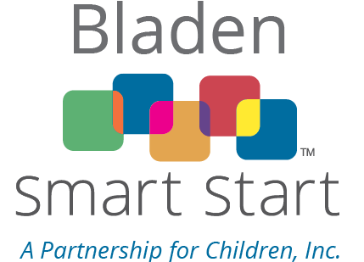
Bladen Smart Start Funding Proposal:
3. SUPPORTING DOCUMENTS

Applicant Name:
Activity Name:

Please complete the following information and attach ONE copy of the supporting documents required and include with the original, signed copy of the full proposal.
a. Does your organization have tax-exempt status? YES NO
If yes, please provide verification that the entity has received official notification of tax exempt status (i.e., IRS determination letter)
b. Does your company have official corporate status? YES NO If yes, please provide verification that the entity has received official corporate status (i.e., Secretary of State Certificate of Incorporation)
c. Federal Tax Identification Number:
Please provide verification of the entity’s federal tax identification or social security number and legal name (i.e., IRS Form W-9)
d. Person authorized to sign the contract, including formal authorization for this individual to enter into contract binding the entity (i.e., bylaws, board minutes, etc.)
Name, Title:
e. Person authorized to sign financial status reports, if different from individual in item “d” above, including formal authorization
Name,Title:
f. Contact information for the contract administrator/coordinator/evaluator
Name, Title:
Mailing Address:
Phone, Fax:
g. Location where the payments should be mailed, if different from above; Mailing Address:
h. Proof of insurance showing current insurance coverage as follows:
- Fidelity Bond policy - A fidelity bond, also known as an employee dishonesty policy, is a form of insurance protection that covers policyholders for losses that they incur as a result of fraudulent acts by specified individuals. It usually insures a business for losses caused by the dishonest acts of its employees.
The policy must be in an amount of at least 50% of the total grant funds provided by Alliance for Children, providing certificate holder status and proof of coverage and naming Alliance for Children as an additional insured or joint loss payee.
If your organization has professional liability insurance, this type of insurance cannot be used in place of the fidelity bond or employee dishonesty policy required for this proposal.
- Workers’ Compensation;
- Commercial General Liability;
- Automobile Liability
- Other Insurance as applicable: (e.g., Professional Liability, Special Events)

