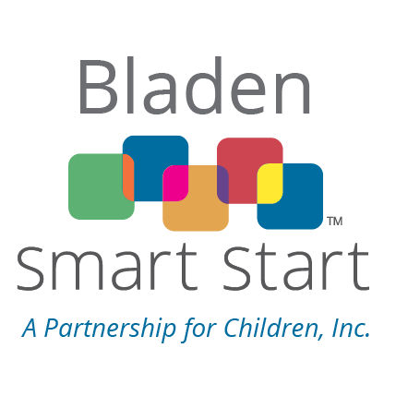
2026-28 APPLICATION FOR FUNDING
Due: May 18, 2026 at 5:00 p.m.
REQUIRED DOCUMENTS CHECKLIST:
☐ 1. Applicant Information
☐ Program Description & Smart Solutions Selected
☐ Logic Model
☐ 2. Budget Narrative / Personnel Listing
☐ 3. Supporting Documents
APPLICANT INFORMATION
Applicant Organization
Legal Name:
Federal EIN:
Mailing Address:
Street Address (if different):
Phone:
Email:
Contract Administrator Name, Title:
Person Authorized to Sign Grant Agreement Name, Title:

Proposal Information

Activity Title:
Have you ever reverted grant funds in the last 5 years? ☐ Yes ☐No If so, in what years, for how much and why?

Financials
Smart Start Funds Requested: $______ Total Annual Project Budget: $_____
Smart Start Request as % of Total Annual Budget ___ %
If funded for the current fiscal year (2025-26), please provide the following information: ALL Sources of Funding for this Activity in FY 2025-26 | Dollar Amount  Pledged or Received | % of Total Annual Project Budget
 | $0
 | $0
 | $0
 | $0

 | $0
TOTAL Project Budget | $0 | 100%

________________________________________________________________
Authorized Signature, Official Title Date
Program Description & Smart Solutions Selected
The Program Description should align with the logic model that follows with attention to the following:
A. Statement of Need: Please make a brief statement about the current need to be addressed by this activity - 50 word limit. (Please note your Logic Model Needs Statement below will overlap with this but must include recent county level information, statistics and/or current research to support the issue(s) being addressed by this activity.)
B. List all Smart Solutions being proposed for funding that identify the model and/or curriculum being utilized. At least ONE Smart Solution is REQUIRED.
C. Description of Services: (one page limit)
Please address the following in details for each fiscal year:
- Service delivery details - frequency, duration, for each specific service(s)/ Smart Solution(s) offered, including any changes for FY2026-27 (if continuing from FY 2025-26)
- target population to be served, including recruitment strategies and eligibility criteria
- how the activity fits into the local service continuum and does not represent a duplication of effort
- activity’s major successes and challenges. (if a continuing program: How have you used lessons learned to enhance your program’s goal attainment?)

Bladen Smart Start: Logic Model FY 26-27 & 27-28
Activity Name: Agency: PSC:
NCPC Smart Solutions: Priority/ EC Profile:
Need Statement  Why? | Priority  Population Who? | Program or Activity Elements (Inputs) What?  (One Smart Solution per row) | Outputs -  Participation  How Many? Projections! | OUTCOMES: By June 30, 2027, …
 |  |  |  | Short Term Goals  So What? | Long-term Impact and relation to Community Level Indicator(s)?
Additional Information
Staffing
Job Title | FTE | Minimum Staffing Requirements
Include one row for each person assigned to this activity. Add more rows as needed. | What portion of a full-time equivalent (FTE) will be required to achieve the desired results with the Smart Solution(s) in this activity? For example, 1.0 means a fully dedicated staff person | Be sure to include required training the staff will need (or has) related to the Smart Solution(s) you are implementing. Do not limit this just to education level and degrees.
Community Collaboration
An activity from Smart Solutions should not be implemented in a vacuum. Describe how this activity will fit into the continuum of services available to your selected target population.
• Who else in your community needs to be involved to help achieve the intended outcomes?
• What will be their role related to the Smart Solution(s)?

